# Experiment No: 01

**Experiment Name:** Experiment on implementation of first come first serve (FCFS) CPU scheduling algorithm.

# Objectives:

* To implement the FCFS CPU scheduling algorithm.
* Calculate waiting time & turnaround time.

**Theory:** CPU scheduling is the process of determining which process in the ready queue is to be allocated the CPU. One of the simplest CPU scheduling algorithms is First-Come, First-Serve (FCFS).

* It is the simplest scheduling algorithm.
* The process that arrives first in the ready queue is executed first.
* It is a non-preemptive scheduling algorithm.

# Source Code:

#include <stdio.h> int main() {

int n;

printf("Enter number of processes: "); scanf("%d", &n);

int arrival[n], burst[n], completion[n], waiting[n], turnaround[n];

// Input: Arrival time and Burst time

printf("Enter Arrival Time and Burst Time for each process:\n"); for (int i = 0; i < n; i++) {

printf("Process %d: ", i + 1); scanf("%d %d", &arrival[i], &burst[i]);

}

// Sorting based on Arrival Time (Bubble Sort) for (int i = 0; i < n - 1; i++) {

for (int j = 0; j < n - i - 1; j++) { if (arrival[j] > arrival[j + 1]) {

// Swap arrival time int temp = arrival[j];

arrival[j] = arrival[j + 1]; arrival[j + 1] = temp;

// Swap burst time

temp = burst[j]; burst[j] = burst[j + 1]; burst[j + 1] = temp;

}

}

}

int time = 0; // Tracks CPU execution time

// Calculate Completion, Turnaround, and Waiting times for (int i = 0; i < n; i++) {

if (time < arrival[i]) {

time = arrival[i]; // If CPU is idle, start when process arrives

}

completion[i] = time + burst[i]; // Completion Time turnaround[i] = completion[i] - arrival[i]; // Turnaround Time waiting[i] = turnaround[i] - burst[i]; // Waiting Time

time = completion[i]; // Update CPU time

}

// Output Process Table printf("\nPID\tArrival\tBurst\tCompletion\tWaiting\tTurnaround\n"); for (int i = 0; i < n; i++) {

printf("%d\t%d\t%d\t%d\t\t%d\t%d\n", i + 1, arrival[i], burst[i], completion[i], waiting[i], turnaround[i]);

}

return 0;

}

# Output:

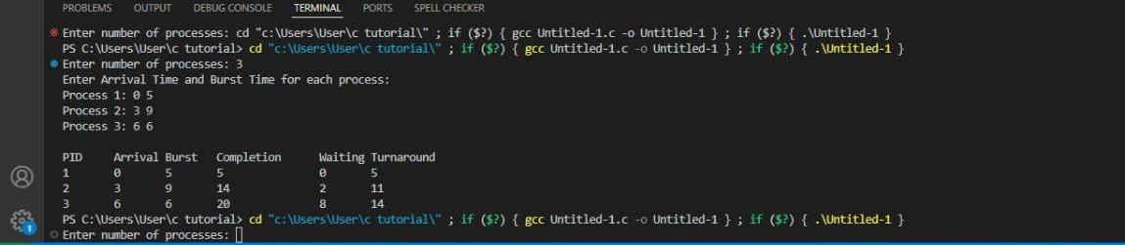

**Discussion:** In this lab, we implemented the First-Come, First-Served (FCFS) CPU scheduling algorithm, which is one of the simplest and most intuitive scheduling methods. The algorithm schedules processes in the order they arrive, making it straightforward to implement. Despite some issues, FCFS can be effective when all processes have similar burst times. The successful implementation of the algorithm in this experiment clearly demonstrated how the scheduling order influences the waiting time and turnaround time of processes, reinforcing key theoretical concepts in CPU scheduling.